Summer Internship Final Reflection Essay
By Sam Solomon

I do think I spent my time well this summer. I have in the past, regretted wasting so much time over the summer, but I feel no shame after coming off of 3 months of proper adult work. I was paid fairly for my time, and I do not regret ever choosing a career over fun. I’m genuinely uncertain as to what I would even do with my time, if it hadn’t been taken up by my internship. The main thing to do in Naples, is go somewhere else. Regardless, I think this was one of, if not the best way to occupy my brain for the summer. I have a better understanding of design choices, and I have learned a litany of vocabulary relating to design, stone, and windows. There a million different names for windows. For example, that window you sometimes see above a doorway? That’s called a transom window. And I cannot walk into any building without consciously noticing if they have floor or crown molding, or anything else that I had to label on Houzz.

Houzz is an online hosting site for realtors or designers who are looking for ideas or sites to show their clients. My task on Houzz was in all actuality, just looking through hundreds of photos at a time, picking the best, taking those, assembling them into a cohesive package of photos, and then finally going through and examining every detail in the photos in order to accurately label them with the correct tags. Oh, and I couldn’t forget to take the best looking photo and note it in the system to show up as the thumbnail. Once that was done, it was just a matter of publishing them.

I feel I can better describe a house to a client, or better recommend a certain style choice to any colleagues who might ask for my judgement, which could further improve my business career and prospects. Knowing the difference between certain types of tile and how they are price could also allow me to better understand a proper cost of installation in any home I may preside in for the rest of my life. Better still, this has opened a door for me into multiple new industries, like construction management or accounting management, since I have experience with multiple types of accounting documents and the proper procedures regarding them. I can better prepare myself for the different types of tasks presented to me as well, as I received a litany of different tasks for day to day operation. From ordering office items (see Fig 1), to fulfilling client requests for new technology to be installed in their winter houses while they are away (Fig 2), my responsibilities were only limited by the day that they were given to me.
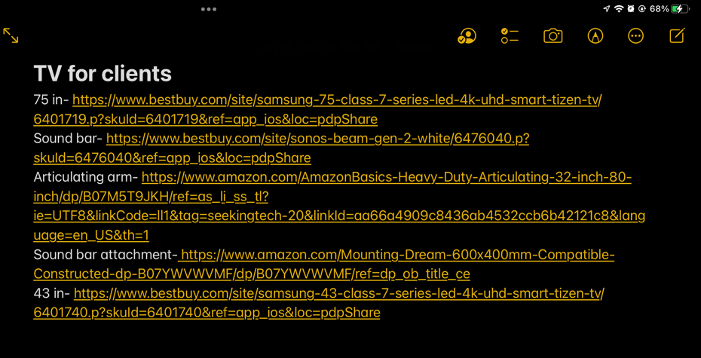
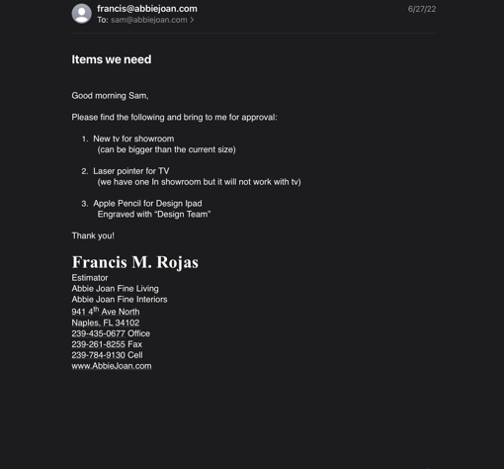
(Fig 1) (Fig 2)

These experiences on the bottom rung of a largely well-run company, will likely impact my decision making in the future, if I am ever in a position of power at a company. I feel I may be more inclined to listen to those lower on the “totem pole” of the company, for their ideas can be just as good, if not better than those at the top’s. I’m reminded of out community outreach program, which after 3 months of deliberation, had still not landed on a name. They were largely divided between Abbie Joan Loves and Abbie Joan Outreach. I was invited to the table, and after a few minutes of deliberation, I landed on Abbie Joan Fine Loving, of course named after our own name of Abbie Joan Fine Living. A simple one letter change had escaped their team for 3 months, but even as an intern, they still valued my input the same as anyone else’s. That was the first time I was consulted on a design choice for a company directive, although it wouldn’t be the last. I was also asked to design a motivational poster to hang around the company, and although my first draft was unilaterally disliked, myself included (Fig 3), I had a second draft (Fig 4) ready for the meeting, as I knew the first draft was just that bad. To save on ink, my third draft eliminated the grey trimmings.

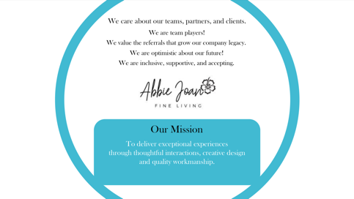
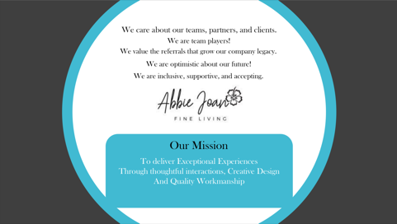
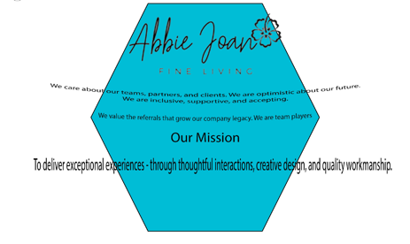
(Fig 3) (Fig 4) (Fig 5)

But even after all of this, I still feel anxious for work. My mind will likely never be sated, but will instead always hunger for endless knowledge, even if that “knowledge” is just mindless drivel, it helps keep my mind occupied for the time. With a stream of constant work, complimented with the knowledge that I’m being paid for my time, kept my mind quite happy over the summer. I believe this leaves me more-so fulfilled than if I had attended training camp, or lazed around, or just worked a retail job over the summer. I have a worthwhile recommendation from a prominent design company in the Naples area, which handily puts me head and shoulders over many other applicants that I might be compared against. I feel confident in my abilities and my workmanship. My time has been well spent.

