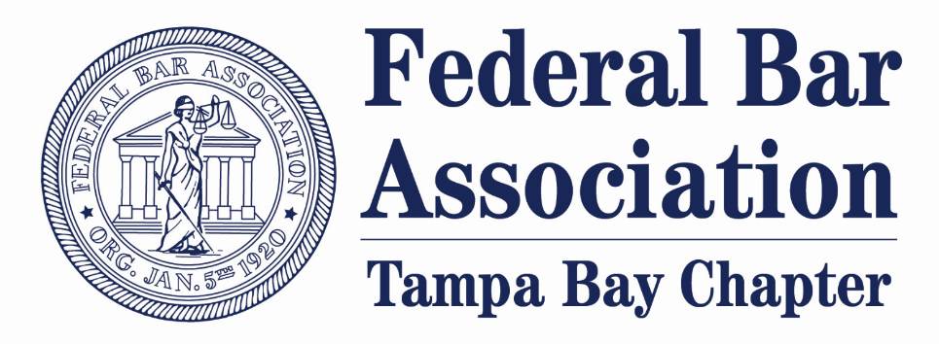

REMINDER

To Sign Up for the FBA’s Mentoring Program

Registration closes on Friday, April 22, 2022

Want to learn more? Click here to access the informational handout (listed under “FBA Mentoring Program Details”)

Interested in serving as a mentor or a mentee?
Fill out the application here (listed under “FBA Mentoring Registration 2022”) and return to Sarah Gottlieb at sgottlieb@freeborn.com and Greg Pierson at gregory_pierson@flmd.uscourts.gov.

