Sylwia Jurkowski
Dr. Kimberly Reiter
How to be an Ancient Historian
11 November 2015
What is the evidence for Christianity’s impact on Constantine The Great’s Architectural Program
“The Roman Emperor Constantine changed the world…in the 21st century, Constantine is… known as the emperor who converted to Christianity [making it] possible for Christianity to become a world religion.” Constantine’s conversion still impacts the world today; he changed thousands of lives in his support and influence of the religion. Constantine’s early life was composed of his worship to the Pagan gods as his father, Constantius, had done before him, but during his years of becoming emperor, he showed sympathy and support to the Christian religion. His architectural program demonstrates, and was influenced by, his support towards Christianity. The most prominent primary scholars of this research are Eusebius, his biographer, Lactanius, his advisor, and Socrates Scholasticus, a 5th century Christian church historian. The most prominent secondary scholars of this research range from 1960s to 2013. In addition, architectural and inscriptional evidence will be consulted.
Primary Source Evaluation
Eusebius, as Emperor Constantine’s biographer, had the task to record the history of Constantine’s life; he does so in his book titled, Life of Constantine. Eusebius provides some context of Constantine throughout his biography; Constantine is celebrated as a person of merit, a saint to the Catholic Church, and a god-sent emperor to the Roman people. The events taking place in Books I and II has Eusebius describing Constantine’s 30 year reign over the empire as an honor bestowed to him by God. He also describes Constantine’s multiple military exploits which took place under the command of his father Constantius, and after he acquired the throne by overthrowing his co-emperor of the East, Maxentius, in a war for the crown and to protect the Christians, as Constantine was by that time a pro-Christian.
During the events of Book III, Eusebius describes religious policies of Constantine and the problems he faced because of them: from the need for a more compassionate government towards the Christians, to the money needed to restore the Christian buildings. Eusebius explains that Constantine’s church building was a way to increase support of Christianity and to spread it throughout his empire. Life of Constantine is one of the first written books of the Roman Emperor Constantine, and Eusebius describes the emperor in the brightest of the holy light.
Apart from writing down the history of the Roman Emperor Constantine, Eusebius is also an important character during Constantine’s reign because he wrote the first primary textual sources about Constantine: Life of Constantine. Specifically in Books I and III, Eusebius wrote about the religious rule of Constantine during his reign, and how his conversion affected his people and influenced the building of churches. In the latter chapters of Book I Eusebius wrote of how, “[Constantine] gave from his own private resources costly benefactions to the churches of God, both enlarging and heightening the sacred edifices, and embellishing the august sanctuaries of the church with abundant offerings.” From this, we see that Constantine was supporting Christianity and being influenced by it so much that he decided to take out funds from his own treasury to ensure that the building of the Christian churches took place, and he even gave funding to decorate these churches in the name of God.
Later on in Book III, Eusebius describes the particular beauty of the Church of our Savior as, “[a] church [which] may surpass all others…in beauty…the details of the building be of such a kind that the fairest structures in any city be excelled by this, and the columns and marbles…[be especially precious].” The Church of our Savior was one of Constantine’s first beloved churches and thus he felt that it had to be a representative for all churches to come. Having Constantine show such devotion to the erection and decoration of this church shows that his architectural program was indeed influenced by Christianity. Eusebius, in the historiography, is the most biased because he praised Constantine, and perhaps felt the need to embellish his architecture. Eusebius was also one of Constantine’s favored bishops, the biographer of this eulogy and his greatest supporter. Thus it can be argued that he was too close to Constantine to provide an objective opinion.
One of Constantine’s advisors, Lactanius, also wrote about Constantine’s support of Christianity through his seven-book defense of Christian faith and ethics against pagan beliefs and practices, The Divine Institutes. Like Eusebius, Lactanius also shows bias towards the emperor because of his numerous personal relations, particularly being one of his advisors and a tutor to his son. Also, he focuses more on the conversion and Constantine’s support of Christianity rather than the architectural program that sprung up by his support. Lactanius can be seen having the same opinion as Eusebius that Constantine was, “the first of the Roman emperors…to know and honour the greatness of the one true God.” Both sources agree that Constantine outshone all the Roman emperors, and as a result of his support of Christianity he had the support of God, which made him more powerful than any leader of the world. Both authors though, fail to critically discuss Constantine’s support over a new religion, and merely emphasize his holiness.
Lactanius does, however, discuss how Constantine put the symbol of Christ on his soldiers’ shields, and wrote about Constantine’s vision of “God”, describing him as “the Roman Emperor not ashamed of Jesus…setting up the cross on the standards of his legions!” Thus, Lactanius provides us with the first evidence of Constantine putting a Christian symbol on a piece of equipment; this possibly affected Constantine in erecting his Christian churches as described by Eusebius. Lactanius described Constantine’s vision as a “miracle”, and because God showed himself to Constantine, he is therefore on par with Jesus, even with his Pagan heart.
The next account of Constantine’s religious program occurs in the 5th century in the writings of Socrates Scholasticus (Socrates), Historia Ecclesiastica. Socrates differs from Eusebius and Lactanius since his bias towards Constantine is less evident because he was not linked to Constantine. Socrates’ opinion is based on a potentially biased source, Eusebius, however, Socrates contributed because he is not beholden towards Constantine. This freedom gives Socrates the ability to write in a more analytical way, but still be as evaluative in his writings. Socrates, like Lactanius, agrees that Constantine converted when he witnessed his “miracle’ vision, explaining in details that “he saw a pillar of light in the heavens, in the form of a cross, on which were inscribed these words, By the Conqueror.” Socrates differs from Lactanius in that his writings emphasized what Constantine believed he saw, rather than, as Lactanius, simply mentioning the miracle vision. Although Socrates does agree that Constantine ordered, “…a standard in the form of a cross to be prepared [after the vision],” he does not write if the cross was placed on the soldiers’ shields. Also, Socrates and Eusebius both agree that when Constantine fully supported Christianity, he “rebuild churches, and enrich[ed] them with splendid offerings.” Rebuilding churches is a part of Constantine’s architectural program and hence Socrates and Lactanius discuss the program independently.
Socrates provides a fresh perspective of Constantine’s view of the Pagans, contradicting Lactanius description of him as a man with a Pagan heart, when he writes that “[Constantine] destroyed the temples of the pagans, and exposed the images which were in them to popular contempt.” And again by his mother, “[the Pagans] erected a temple to Venus, [the emperor’s mother ordered] the statue to be thrown down, the earth to be removed, and the ground entirely cleared, [for] a magnificent church.” In Constantine’s family, it shows that they have removed themselves from their Pagan ancestry, and in supporting Christianity they both destroyed Pagan places of worship and built Christian ones.
Secondary Sources from the 1960’s to the 1980’s
In analyzing our contemporary secondary sources, it is to be noted that the primary sources focus more on the evaluation of Constantine’s character from the point of view of his Christian faith, while the secondary sources deepen the historical research by analyzing the purpose of Constantine’s faith, and its effect on his architectural programs.
The secondary sources, specifically from the 1960’s to the 1980’s, include the most prominent scholar Richard Krautheimer and another scholar by the name of William MacDonald. Krautheimer’s viewpoint references Constantine’s views on Christianity and how the architecture was influenced. Krautheimer solidifies his research with the comparisons between each of those buildings. Krautheimer writes that “the position and organization of the Church during… [the] years 313 to 337 pivots round the person of Constantine.” He thus states that the Church’s place in Rome was centered around Constantine and his relations to the Church. He also states that Constantine viewed himself as the “the Divine incarnate, Invincible Sun, the Seat of Justice.” This leads to several questions: can the Invincible Sun be referring to the Pagan views of the Sun or is Constantine referring himself as a Son of God which would make him holy in the Christian sense? Or can the Invincible Sun be referring to ‘Sol Invictus Mithras,’ whom Constantine was affiliated to and never disowned it, not even when he openly embraced Christianity and declared himself to be ‘God's servant.’ However, Krautheimer failed to discuss Constantine’s affiliation to Mithraism, and only in the later secondary sources do we find research of that affiliation in the form of coins. Krautheimer also mentions that Constantine believes “he had been divinely appointed to lead the Christ’s Church to victory.” Thus, while his spiritual views may be questioned, according to Krautheimer, Constantine’s dedication to the victory of the Church and his belief that he is the only person capable of doing so can clearly be seen in the mosaics and buildings he creates.
The path to this victory can be seen when Krautheimer writes that “Christianity under Constantine had to find a new architecture of a higher order, public in character, resplendent in material, and spacious in layout.” Christianity influenced Constantine so much that he had to change all of his architectural methods to accommodate his attachment to the religion. Constantine goes on to building churches in areas where people did not go to Mass often, and though there was no standard method of building as can be seen from Early Roman monuments. These architectures all had the same purpose in serving God. To end with Krautheimer’s contribution, is his statement that Constantine’s architecture was indeed the last phase of the architecture of Late Antiquity.
William MacDonald, while he never references Krautheimer’s research, he does share similar views and findings on Constantine’s architectural program. MacDonald agrees that Constantine used old Pagan buildings of worship and converted them to Christian Churches. This can be tied into MacDonald statement that “early Christian art bears eloquent testimony, [and] sought to endow life with meaning and values which the aging Roman imperials…could no longer provide.” The old buildings had no meaning, no life in them anymore; Constantine sought to replace them with churches and artwork that could make his people convert. In MacDonald’s view, Constantine’s architects did use some Roman Imperial architectural motifs in order to build his churches, thus he disagrees with Krautheimer’s belief that Constantine represent discontinuities with Roman strategies. MacDonald does agree with Krautheimer in that Constantine did view himself as someone better than anyone, not because he was Emperor but because he “made Christianity licit, and not only openly allied himself with the Church, but assumed within it an anomalous but authoritative station.” He also agrees with Krautheimer in that there is no basic kind of Constantinian Church building, as they utilized various methods during construction. MacDonald has a similar bias to Krautheimer in that they both believe that Constantine was completely influenced by Christianity and supported it enough to build for the religion and make his people worship its God.
Secondary Sources from since 2000
Krautheimer and MacDonald dominated the historiography on this topic to the extent that it was not approached further until the year 2000 by Nancy H. and Andrew Ramage. There we find that there was a discontinuity in historiography in 2004 by R. Ross Holloway’s book Constantine and Rome, where he opposed all of Krautheimer’s and MacDonald’s views on Constantine. These later secondary sources bring two different ways of dealing with the evidence of Constantine’s conversion to Christianity. There are the sources who keep to the trend of Christianity’s influence on his architectural program, and there are other sources, namely the Ramages’, Charles Odahl, and Alan Doig who deal with the architecture as well as the art.
The Ramages’ viewpoints on Constantine’s architectural program differ from all the previous sources, both primary and secondary, when they explain how Constantine’s support of Christianity did influence the architecture of his time, and it also “began the trend where official art…started to lend its aura to the glory of the Church.” They state that “Constantine made it possible to mix [Christianity and Paganism] and [it thus] shaped the iconography for the emperors to come…” Constantine therefore had the power to mix both Christianity and Paganism together to create art from both. This makes one rethink Constantine’s stance with both faiths, as most of the previous scholars agree that he was more affiliated with Christianity once he became emperor; the Ramages, however, state that Constantine was still affiliated with both Christianity and Paganism. The Ramages’ argue that the final phase of transition from Roman Art to Constantine’s Christian Art occurred because he accepted and encouraged Christianity, and he also was the Emperor of Rome; therefore, he can do whatever he pleases. This contradicts when they later wrote that, “Christianity …dominat[ed]…almost all images [that] were intimately linked with religious purposes.” The Ramages’ provide a contradicting view in their research of Constantine, but they also present the possibility that architecture and art were influenced by the emperor’s affinity with Christianity and Paganism.
By the time that Charles Odahl begins to write, the scholars have moved away from the evaluative approach to a more analytical approach of Constantine’s support of Christianity. Odahl’s research rivals that of 1960’s scholar Krautheimer, because of the amount of multiple primary sources he included, and the more analytical approach he takes. However, Odahl has more interest in the conversion rather than the architectural evidence. Odahl begins his book noting Constantine’s belief that since his predecessors followed the pagan cults and persecuted the church, they all met with unfortunate endings. Therefore, when Constantine marched on Maxentius in the year 312 CE, Constantine “invoked…the “Highest God”…in prayer for aid and power…believing that he received an answer…he decided to [use] the “celestial symbols” of Christ…on the arms of his troops.” This was the vision that Constantine witnessed before the battle, but Odahl does not explain what sort of vision Constantine received like Socrates, but he does agree with Socrates and Lactanius in that he did indeed receive one. After Constantine won the war with Maxentius and was crowned emperor, he still worshiped Paganism, “Although Constantine built pagan temples and worshipped [there], he refused to harm the followers of the Christian God.” Odahl, from this statement, unlike previous scholars, shows us that Constantine was Pagan during his reign and only protected the Christians; he does not convert over the vision as Socrates believes, nor does he view himself as some divine person as Krautheimer states.
However, Odahl explains that with each passing day Constantine became more and more attached to the Christian faith, and that made him ultimately think that “he was a recipient of divine benevolence from [God] and the fear that he could lose divine favor by failing to protect the Catholic Church…” This shows that Constantine realized that if he wanted to still receive the glory and grace of God he had to commit in protecting and building the Catholic Church. The most prudent way of protecting the church was expanding it while destroying the pagan temples. Odahl also analyzes the erection of the church by Constantine’s mother, which was also approved by Constantine, “[she] ordered the pagan idols and altar be destroyed and that a Christian church be constructed in their place.” This analysis is different from Socrates, but has the same message that Constantine is now further from his Pagan ancestry and more supportive of his new Christian one.
Odahl is also one of the only scholars to write of the propaganda associated with Constantine’s architectural program, stating “he employed imperial propaganda to spread the Christian faith through[out] Roman society.” Imperial perhaps meant that he used his advisors, to support Christianity and by doing so he showed the Roman people that they should too; this is a definite example of a top-bottom takeover, meaning that Christianity first hits the top official, Emperor Constantine, and once he is controlled by the religion, everyone else below him follows him. Odahl further states that the, “emperors…use[d] the imperial coinage as a means of propaganda…[through] the frequently changed reverses [which] announced…religious beliefs.” Roman coins were sent out throughout the empire with the belief that once the people receive them they will marvel at the images and writings inscribed on the reverse, therefore becoming influenced by the inscription. Odahl provides us with a more analytical research on Constantine’s conversion and architectural program, stating all the details from the primary sources, not just the well-known ones.
Constantine and Rome, written by Holloway, was the discontinuity mentioned above as his research gave an extremely negative viewpoint towards Constantine. His first message to us on Constantine is that “…Constantine was fighting to win the empire for himself, not for the Christians.” Already we see that Holloway does not believe that Christianity influenced Constantine or his architectural program. As a modern scholar, it is seen that Holloway is more interested in Constantine’s “conversion” to Christianity rather than his architectural program. Holloway bluntly states that “Constantine’s approach to Christianity…was not a conversion, it was accommodation.” This statement suggests that when Constantine saw Christianity growing in his empire he did not outright worship it; instead he altered his view of it, but kept to his pagan ways. Holloway also gives us a history on how Christianity was treated in the Roman Empire before Constantine’s treatment towards it; that history was full of bloodshed, hatred and zero tolerance whatsoever to anyone who practiced it.
Holloway also gives us an account of how Constantine had coinage made with the cross during 317-18 CE despite the Romans current hatred for Christianity; the appearance of the cross was a rare occurrence in Constantinian currency. Most of his coinage had Constantine with the Sol Invictus on the front while on the back Constantine is on horseback preceded by Victory. This can be related back to the questions given by Krautheimer’s statement on how Constantine viewed himself as Christianity’s emissary. The coins themselves provide us a view into who Constantine valued above all; on coins Sol is always in front of Constantine, thus this portrays Constantine’s worship of him as he is the Mithras God. However, Holloway explains that this coinage instead shows Constantine as a follower of paganism, with no inclination to be associated with Christianity. It is known that Constantine was indeed a Pagan up until his final moments of life when he converted. However, there is plenty of evidence from the previous sources that prove that Constantine was indeed influenced by Christianity throughout his life. Even though there is this discontinuity, the whole trend remains continuous by the later scholars of Allan Doig, Jonathan Bardill, and D. S. Potter.
In Alan Doig’s book Liturgy and Architecture: From the Early Church to the Middle Ages, he shows the evidence that Constantine’s architectural program influenced the writings of the liturgy during Mass. Doig states that there is a “direct correspondence between...the liturgical language and specific elements of its surrounding, which are almost always architectural.” He also adds on that the artwork done during Constantine’s reign was influenced by his support of Christianity, that “paintings and graffiti also help to reconstruct their theological outlook.” Doig’s view on Constantine, his architecture and Christian belief are similar to those of Krautheimer and MacDonald rather than Holloway. He views Constantine as “the leader of the formerly oppressed cult” and also states that “a change in the form of worship [can] bring more changes to the building.” We can thus say that Doig sees Constantine as a leader of a cult with strong a tie to Christianity, and as a result of that tie and his influence, the architecture of that time changed with a change in worship. However, Doig can be seen to slightly agree with Holloway’s statement that the Romans had no tolerant for Christianity. Doig, however, states that there were also other leaders in the Middle East and African regions of the Roman Empire who did not tolerate Christianity, which makes the Roman’s intolerance irrelevant.
In addition to drawing on other author’s research and viewpoints, Doig also writes on Constantine’s biographer, Eusebius. Doig writes on how Eusebius preached in the Cathedral of Tyre, and how he praised and advocated that “the building of churches, and their being filled with beautiful votive offerings, is proof of the power of the King of Heaven.” Eusebius means that the churches they built stand as proof that God exists so they must worship him. With Constantine’s churches and basilicas were so grand and opulent, his bishops and priests felt the need to write a longer, more transcendent liturgy in order to accommodate their new surroundings. Doig goes on to explain how each of Constantine’s buildings were being built and where. He also writes on other author’s views of Constantine and his architectural program, and compares how each of Constantine’s buildings had similar architecture though they were made with various methods.
In Jonathan Bardill’s work of Constantine Divine Emperor of the Christian Golden Age, it analyzes Constantine as an emperor, pagan and a Christian; while he also examines the evidence of the architectural program. Bardill continues the trend set up by Odahl in showing that the program was also seen in coinage. The symbol known as the chi-rho, was seen on a coin with the inscription, “In Signo Christi, [which referred] to the words Constantine saw in the sky at the time of his vision.” Bardill goes on to state that this chi-rho symbol was the one Constantine used on the standard, as mentioned earlier by Lactanius and Socrates. Also, with Odahl, he agrees that Constantine in the beginning showed a “tolerant attitude towards [the Christians] as reflected in the policy on religious freedom.” Bardill therefore agrees, like the Ramages and Odahl, with the fact that Constantine was a Pagan with only an affinity towards Christianity. Bardill is also the first source to describe what kind of basilica was being built in Constantine’s reign, granted that Krautheimer and MacDonald both review and compare the basilicas they never mention what kind. The basilica that Bardill refers to is known as the aisled basilica, a prime example of the Church of the Nativity, “the roof space was divided into nave and flanking aisles by linear colonnades, and in some cases the aisles were of two stories.” Bardill does not, however, explain if Constantine needed the support of money in order to erect his churches as Eusebius explained, nor would he need the money to erect a temple for another god. As the years went by in Constantine’s reign, so did his growing support of the Christian community by the building of his namesake city, Constantinople. Constantine by then was a great supporter of Christianity and that support influenced him to build an entire city in the name of God, “the city [he explains] which we have endowed with the eternal name at God’s command.” The entire holy city of Constantinople can thus be viewed as the greatest part of the architectural program because the entire city is influenced by Christianity. Out of all of the scholars Bardill analyzes every part of Constantine’s life and the architectural program influence of Christianity.
The last of the secondary sources goes by the name of D.S. Potter and his work titled Constantine the Emperor. The scholar follows in the footsteps of Bardill in his usage of the primary sources of Eusebius and Lactanius, however, Potter, like Odahl, does stay analytical in his research of Constantine in the interest of his conversion rather than the architecture. Potter continues the tradition of having Constantine’s vision before battle, but unlike Lactanius and Socrates, he agrees with Bardill that the chi-rho symbol was present on Constantine’s men, “Constantine’s men appear to have displayed a new symbol…[the] letter chi…with the letter rho.” The chi-rho is a symbol of Christ and Potter agrees with the fact that it was used. Potter also semi-agrees with the previous scholars that Constantine was Pagan but, Potter states to one “God” and it does not have to be the Christian one, “By 315…his victory needed to be seen as a victory for the god of Constantine, but not necessarily as a victory for the Christian God.” Potter therefore can be argued to share similar beliefs to Holloway, in that Constantine did not outright worship the religion, but changed his view of it. Potter also writes on Constantine’s conversion in death and how according to Eusebius, he “summoned an assembly of bishops, telling them that…he wished to be baptized.” What Potter fails to incorporate in his research is the reason why Constantine converted so late, and instead focused on incorporating that both a Christian bishop and a Pagan prefect were beside him on his deathbed. From this, Potter can be viewed as having duel views of Constantine’s conversion and that the architecture of the time was not as significant as the symbols and the need to have a “God” was.
Combining all of the research shows that there indeed is evidence that Constantine’s support for Christianity gave way to his massive architectural program. The primary sources give the most evaluative and bias views towards the program, while the first secondary sources are a bit more analytical and still evaluative, the last secondary sources becoming mostly analytical, with the exception of the slight discontinuity. Most of these sources agree with Constantine’s methods and support of Christianity, but some sources only see the conversion and ignore the program altogether. There should also be further exploration of the discontinuity in order to gain more information on that idea, and to see if Holloway’s points are valid or is he just an extremely negative scholar with a one-way viewpoint.

List of Illustrations-
Image 1-
Church of the Nativity- Constantine’s mother built this church over the supposed site of the birth of Christ in Bethlehem
Images 2-3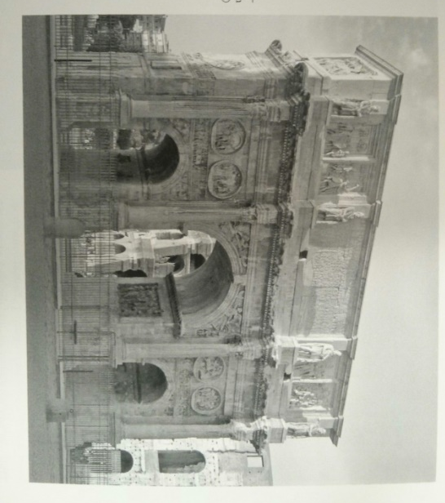 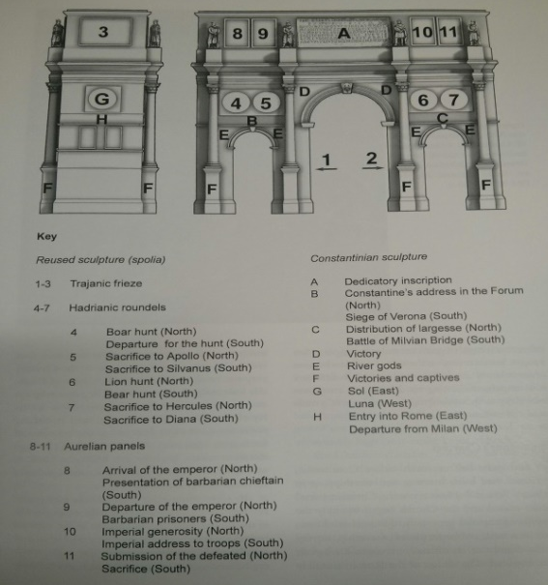
Arch of Constantine- was commissioned by the Roman Senate to commemorate Constantine victory over Maxentius at the Battle of Milvian Bridge, the Arch firmly shows Constantine as a warrior of the Pagan Gods
Image 4- 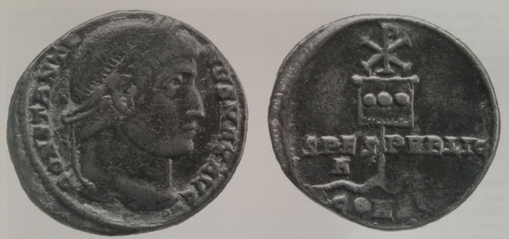
Coin of a Chi-Rho- Obverse side shows the head of Constantine. Reverse side shows serpent pierced by a standard topped by the chi-rho monogram. A.D. 327 minted coin in Constantinople.
Image 5-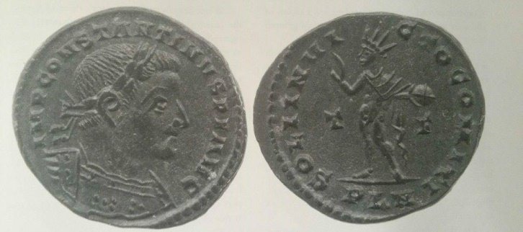
Coin of Sol Invictus Mithras – Obverse side shows the head of Constantine. Reverse side shows Sol with a globe in his left hand and his right arm is raised.
Image 6- 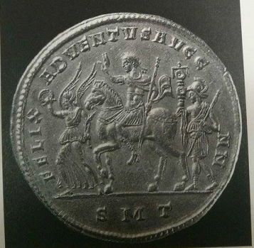
Coin of Sol Invictus(Mithras) and Victory – Obverse side shows the head of Constantine overlapping the one of Sol. Reverse side shows Constantine on horseback preceded by Victory.
Image 7 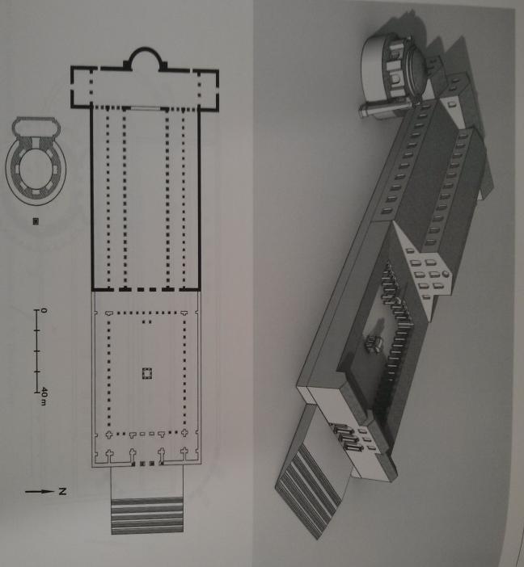
Basilica of St. Peter- the old basilica was the only one of Constantine’s church to enclose a shrine of a Roman matyr, as of today does not exist
Image 8 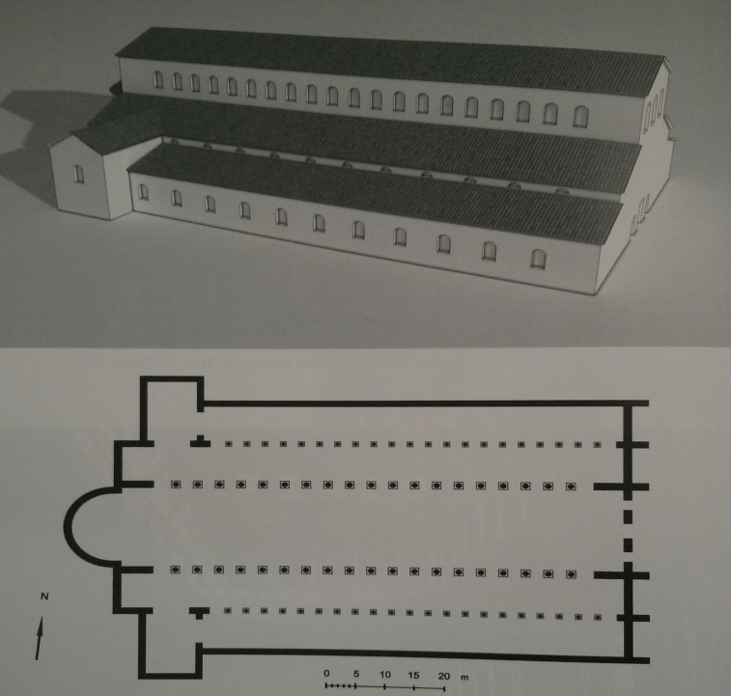
Archbasilica of St. John Lateran- the first of Constantine’s church and the founder of his entire architectural program
Image 9 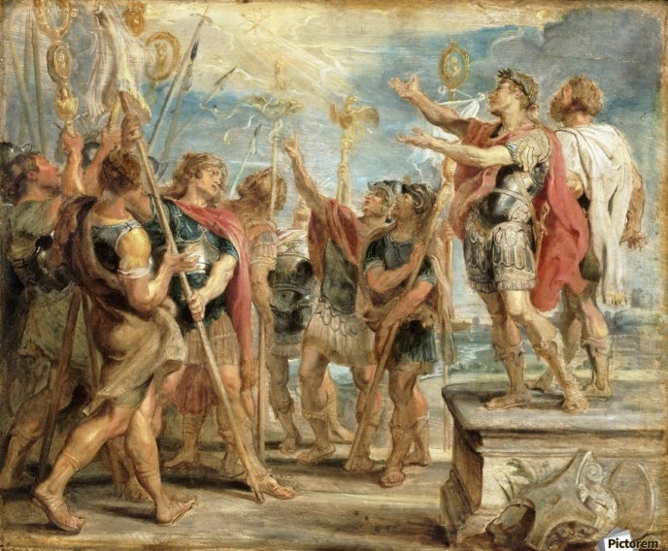
The Emblem of Christ Appearing to Constantine- part of the tapestry that depicts Constantine’s vision and the chi-rho symbol
Image 10 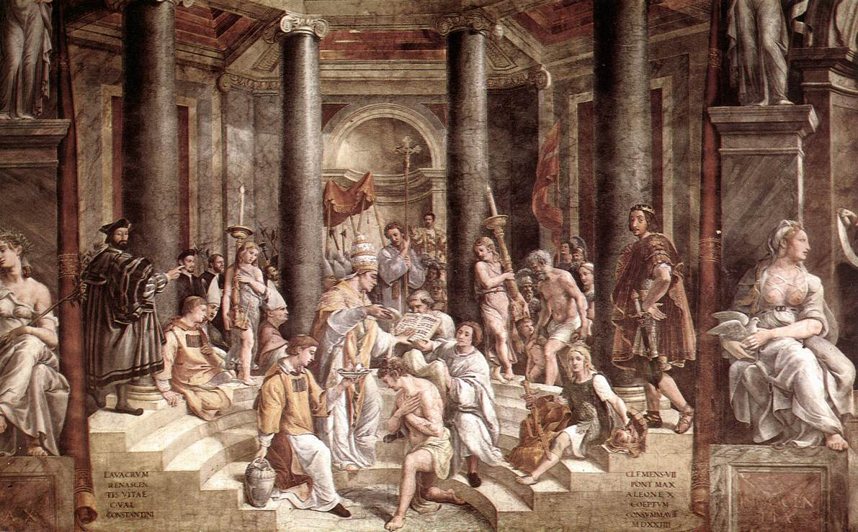
The Baptism of Constantine- Constantine kneels to receive the sacrament from Pope Sylvester inside the Baptistery of the Latera

Bibliography
Allan Doig, Liturgy and Architecture: From the Early Church to the Middle Ages, (Aldershot,
England: Ashgate, 2008).
Assistant of Rapheal, The Baptism of Constantine, 1517-1524, fresco, Vatican Museums, Vatican City.
Charles M. Odahl, Constantine and the Christian Empire, (London: Routledge, 2004).
D. S. Potter, Constantine the Emperor, (Oxford: Oxford University Press, 2013).
Eusebius Pamphilus, A Select Library of the Nicene and Post-Nicene Fathers of the Christian
Church, eds. Philip Schaff and Henry Wace, ed 2, vol. I, (Grand Rapids: WM. B. Eerdmans Publishing Company, 1955).
Jonathan Bardill, Constantine, Divine Emperor of the Christian Golden Age, (Cambridge: Cambridge University Press, 2012).
Lactanius, "The Divine Institutes," The Ante-Nicene Fathers, trans, Rev. William Fletcher and
James Donaldson, ed, A. Coxe, vol. VII, (Grand Rapids: Wm. B. Eerdmans Publishing
Company, 1886).

Nancy H. and Andrew Ramage, Roman Art: Romulus to Constantine, Third ed, (Upper Saddle
River, New Jersey: Prentice Hall, 2001).

Peter Paul Rubens, The Emblem of Christ Appearing to Constantine, 1662, oil on panel, 18 3/16
x 22 1/16 inches, Philadelphia Museum of Art, Philadelphia.

R. Ross. Holloway, Constantine & Rome, (New Haven: Yale University Press, 2004).

Richard Krautheimer, "Constantine Church Building," Early Christian and Byzantine
Architecture, (Baltimore, Maryland: Penguin Books, 1965).

Socrates Scholasticus, A Select Library of the Nicene and Post-Nicene Fathers of the Christian
Church, eds. Philip Schaff and Henry Wace, ed 2, vol. II, (Grand Rapids: WM. B.
Eerdmans Publishing Company, 1955).

William L. MacDonald, Early Christian & Byzantine Architecture, (New York: G. Braziller,
1962).

D. S. Potter, "Introduction," Constantine the Emperor, (Oxford: Oxford University Press, 2013), P. 1.
Eusebius Pamphilus, A Select Library of the Nicene and Post-Nicene Fathers of the Christian Church, eds. Philip Schaff and Henry Wace, ed 2, vol. I, (Grand Rapids: WM. B. Eerdmans Publishing Company, 1955).
Eusebius Pamphilus, “Book I, Chapter XLII,” A Select Library of the Nicene and Post-Nicene Fathers of the Christian Church, eds. Philip Schaff and Henry Wace, ed 2, vol. I, (Grand Rapids: WM. B. Eerdmans Publishing Company, 1955).
Eusebius Pamphilus, “Book III, Chapter XXXI,” A Select Library of the Nicene and Post-Nicene Fathers of the Christian Church, eds. Philip Schaff and Henry Wace, ed 2, vol. I, (Grand Rapids: WM. B. Eerdmans Publishing Company, 1955).
Lactanius, "The Divine Institutes," The Ante-Nicene Fathers, trans, Rev. William Fletcher and James Donaldson, ed, A. Coxe, vol. VII, (Grand Rapids: Wm. B. Eerdmans Publishing Company, 1886).
Lactanius, "The Divine Institutes, Chapter I: Religion and Wisdom," The Ante-Nicene Fathers, trans, Rev. William Fletcher and James Donaldson, ed, A. Coxe, vol. VII, (Grand Rapids: Wm. B. Eerdmans Publishing Company, 1886).
Lactanius, "The Divine Institutes, Introductory Notice," The Ante-Nicene Fathers, trans, Rev. William Fletcher and James Donaldson, ed, A. Coxe, vol. VII, (Grand Rapids: Wm. B. Eerdmans Publishing Company, 1886).
Ibid.,
Socrates Scholasticus, A Select Library of the Nicene and Post-Nicene Fathers of the Christian Church, eds. Philip Schaff and Henry Wace, ed 2, vol. II, (Grand Rapids: WM. B. Eerdmans Publishing Company, 1955).
Socrates Scholasticus, “Chapter II,” A Select Library of the Nicene and Post-Nicene Fathers of the Christian Church, eds. Philip Schaff and Henry Wace, ed 2, vol. II, (Grand Rapids: WM. B. Eerdmans Publishing Company, 1955).
Socrates Scholasticus, “Chapter III,” A Select Library of the Nicene and Post-Nicene Fathers of the Christian Church, eds. Philip Schaff and Henry Wace, ed 2, vol. II, (Grand Rapids: WM. B. Eerdmans Publishing Company, 1955).
Socrates Scholasticus, “Chapter XVII,” A Select Library of the Nicene and Post-Nicene Fathers of the Christian Church, eds. Philip Schaff and Henry Wace, ed 2, vol. II, (Grand Rapids: WM. B. Eerdmans Publishing Company, 1955).
Richard Krautheimer, "Constantine Church Building," Early Christian and Byzantine Architecture, (Baltimore: Penguin Books 1965), P. 17.
Ibid., P. 17.
Please refer to the list of illustrations image 5 for an example of a Mithras coin.
Ibid., P. 17.
Ibid., P. 19.
William L. MacDonald, “Introduction,” Early Christian & Byzantine Architecture, (New York: G. Braziller 1962), P. 12.
Ibid., P. 19.
R. Ross. Holloway, Constantine & Rome, (New Haven: Yale University Press, 2004).
Nancy H. and Andrew Ramage, Roman Art: Romulus to Constantine, ed 3, (Upper Saddle River: Prentice Hall, 2001), P. 312.
Ibid., P. 335.
Ibid., P. 335.
Charles M. Odahl, Constantine and the Christian Empire, (London: Routledge, 2004), P. 1.
Ibid., P. 92.
Ibid., P. 136.
Ibid., P. 219.
Ibid., P. 2.
Ibid., P. 13. Please also refer to the list of illustrations images 4, 5, and 6 for examples of propaganda coins.
R. Ross. Holloway, Constantine & Rome, (New Haven: Yale University Press, 2004). P. 2.
Ibid., P. 3.
Ibid., P. 3.
Ibid., P. 15. Please refer to the list of illustrations image 6 for a representation of this coin.
Allan Doig, “Introduction,” Liturgy and Architecture: From the Early Church to the Middle Ages, (Aldershot, England: Ashgate 2008), P. xxi.
Ibid.,
Ibid.,
Ibid.,
Ibid., P. 27.
Jonathan Bardill, Constantine, Divine Emperor of the Christian Golden Age, (Cambridge: Cambridge University Press, 2012).
Please refer to the list of illustrations image 4.
Ibid., P. 220. Refer to list of illustrations image 4 for an example of one of the coins.
Ibid., P. 212.
Please refer to the list of illustrations image 1 for the diagram of the Church of Nativity.
Ibid., P. 231. Refer to footnote 32 for an example.
Ibid., P. 222.
D. S. Potter, Constantine the Emperor, (Oxford: Oxford University Press, 2013).
Ibid., P. 143.
Ibid., P. 169.
Ibid., P. 291.
Ibid., P. 291.
Jonathan Bardill, Constantine, Divine Emperor of the Christian Golden Age, (Cambridge: Cambridge University Press, 2012), P. 260. Diagram of the Church of Nativity.
Ibid., P. 94. Image of the Arch of Constantine.
Ibid., P. 229. A key to all the sculptures on the Arch of Constantine and their locations.
Ibid., P. 143. One of the “vision” coins that were minted, and it also shows his role as a savior by the images on the coin.
Ibid., P. 87. These are one of the propaganda coins that appeared during the time of Constantine, however, for the last 30 years of his reign, these ‘Sol’ coins vanished.
Ibid., P. 93.
Ibid., P. 246. A diagram of the old St. Peter’s Church during the time of Constantine.
Ibid., P. 240. Once known as the Church of our Savior, but changed on Constantine’s command.
Peter Paul Rubens, The Emblem of Christ Appearing to Constantine, 1662, oil on panel, 18 3/16 x 22 1/16 inches, Philadelphia Museum of Art, Philadelphia.
Assistant of Rapheal, The Baptism of Constantine, 1517-1524, fresco, Vatican Museums, Vatican City.

